Kaitlyn Perham

SIE 521 Final Project

Defensible Space – Does it impact the survivability of structures during a wildfire?

In 2020 alone, nearly 10,000 structures were destroyed by wildfires in California. The increase in destruction in recent years has caused for a call to action by members of the public, community organizations, legislators, and others. Regulations to enforce defensible space and other structure hardening are increasingly on the forefront of many discussions to decrease the severity of losses during wildfire events. Expansion of development in the Wildland Urban Interface in California has ignited discussions on issues of housing regulations, density, and home affordability. Can defensible space mitigate these issues effectively, or should expansion of housing developments in the WUI be reconsidered?

Objective

Defensible space may be a key determining factor in the survivability of structures, but the extent of protection from damage is not yet clear. Key factors in risk to structures that have been well defined in the field of fire science include the surrounding vegetation and topography of the area surrounding the structure. Recent studies (Alexandre et al 2016) have examined the role of spatial arrangement of structures and the role that the Wildland Urban Interface has on loss susceptibility. This analysis will determine if the vegetation in the 100 foot and 30 foot zones have an impact of survivability. The WUI zones delineated by the US Forest Service will be used to analyze distinct zones of vegetation and housing arrangement. I hypothesize that the clearance in the 100 ft zone will have the greatest impact on survivability in the sparsely populated, forested WUI zones. The clearance in the 30 foot zone will likely not increase survivability in these areas, but might be effective in the intermix and lower density/lower vegetation areas defined in the WUI classes.

Similar Studies

Several studies have examined the role of spatial arrangement, defensible space, and home hardening structures in the role of damage from wildfires. A 2016 study (The relative impacts of vegetation, topography and spatial arrangement on building loss to wildfires in case studies of California and Colorado, Alexandre et all 2016) found that the placement of structures in Intermix and Interface areas of the wildland urban interface affected outcomes in destroyed structures, but the effect was regional and did not show significance in all regions of the study. A recent study (Kramer et all 2019) showed that low fuel areas that interface and intermix with the WUI were more likely to have significant structure loss than rural areas. Additionally, another study in 2014 (Syphard et al) showed that defensible space directly adjacent to the home improves structure survivability, but the protection does not extend outside the 100 ft and 30 ft zones.

Data

Several public datasets were used in this analysis. CalFire conducts damage inventories as soon as possible following a wildfire, collecting information on structures in the immediate areas affected. Collected information includes destroyed, affected, and undamaged structures. All structure types are collected (Residential homes, outbuildings, commercial buildings, infrastructure) with an assessment of the structures properties that includes (but is not limited to) roof and siding type, and whether eaves and ventscreens are present.

These loss points were matched with Microsoft’s open structure footprint data. Using the structure footprint is essential to determining the 30 foot and 100 foot defensible space zones for each structure with increased accuracy. The point data were joined to structures in QGIS after using the ‘Hub Distance’ tool in QGIS to assess the accuracy and average distance to the structure centroid. For loss data information that did not land in a structure polygon, the nearest structure within 100 feet was used. For points that were not present or within 100ft of a structure, a buffer of 50 feet around the point was used to approximate a structure based on the average area of structures in the matched structures. Then, buffers of 30 and 50 feet were generated around the structure data to create the zones for analysis. The majority of the loss data points were placed within 100 feet of the structure, but it is possible the data do not align with the correct structure due to the nature of the data collection method. The data are collected in the field by damage assessment workers that may not be able to collect the point directly adjacent to the structure due to the hazardous nature of collecting data in the field.

Defensible space incorporates the vegetation in the immediate space adjacent to the structure. The two defensible space zones defined by CalFire are set at 100 feet from the structure, and 30 feet from the structure.

1-meter NAIP data were streamed via and open access Microsoft Azure bucket to calculate the NDVI for each NAIP quad image in the study area. The most recently available imagery from 2018 was used. NDVI was calculated for each image using the red and near infrared bands( (NIR-Red)/(NIR+Red)), and then reclassified into vegetation/no vegetation based on an NDVI threshold of 0.1. NDVI is used as a proxy for the presence of vegetation, but it is not an indicator of fuel type or density, which affects wildfire risk at an given location. Dense shrubs and trees pose more of a risk than maintained lawns, but NDVI cannot be used alone to distinguish these fuel types. NDVI classification problems can also occur, especially in areas of steep slope where shadows are prevalent in the imagery and are not captured accurately by the NDVI calculation. A visual assessment of the output NDVI reclassification showed some areas where this was an issue in some areas where heavy shrubs predominate the vegetation on steep slopes.

WUI data from the US Forest Service were intended to be used to stratify the damage assessment data for analysis, but the data distribution in the resulting strata were too uneven to be used for analysis. These WUI types will instead be used as a predictor variable in the analysis. The WUI classes in the data include approximated density of housing units and vegetation type to characterize patterns of development that occur to approximate where the wildlands and structures interface. A major disadvantage from this dataset is the age of the data and the question being examined – development in the WUI. The data is from 2010; a more recent release is not yet available. Newly constructed neighborhoods may not be accurately classified, which may affect the analysis. Additionally, the spatial resolution is lower than the high resolution of analysis of vegetation data from NAIP. This WUI dataset was created from the 30m National Land Cover data, and the housing density comes from census tract estimates, which vary greatly in size and therefore affects the output housing density information. This contrasts with the high resolution analysis of the vegetation in the 30 and 100 foot zones around individual structures.

Methods and Analysis

The reclassified NDVI was then assessed using zonal raster statistics for each structure’s 30 and 100 ft defensible space zone. The count of pixels within each zone were used to calculate the percentage of vegetation within each structure’s 30 and 100ft zone.

To create an equal amount of Damage/No Damage observations for analysis, a random sample of 5,000 points for each outcome was used. Using a general regression model, several variables were examined individually and concurrently.

|  |  |
| --- | --- |
| **Variable** | **Description** |
| PctVeg30 | Percent of 30ft zone covered in vegetation |
| PctVeg100 | Percent of 100ft zone covered in vegetation |
| WUICLASS10 | 2010 WUI classes |

As predicted, the 100 ft defensible space zone seemed to have the most impact on Damage / Not Damaged outcome. The vegetation in the 30 ft zone also played a strong role in survivability based on the p-value and log odds for the general linear model.

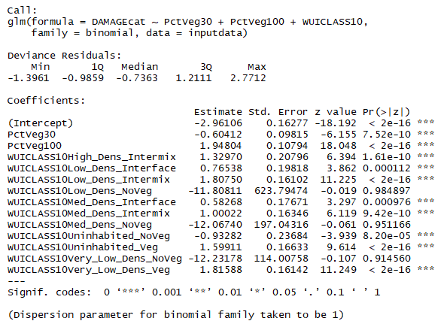

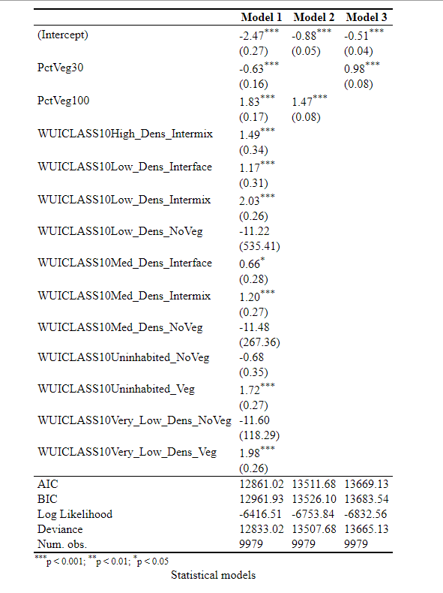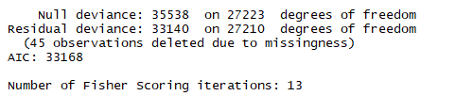

The results show high significance for WUI classes and the defensible space zone variables. There is an even distribution of damage/no damage observations, but the WUI classes are heavily dominated by Low Density Intermix and Very Low Density Veg which may alter the results for the remaining categories. The distrbution of data in the WUI classes were not sufficient to stratify the data using WUI classes, which may provide more of a control for the situational aspects of wildfire risk for a structure. Numerous other factors could be studied if the DINS data were more complete, including structure hardening attributes.

In conclusion, the vegetation in proximity to the structure affects the structure’s survival in the event of a wildfire. The large publicly available DINS dataset enabled this analysis; the large number of observations with good spatial accuracy will allow for further research of potential mitigation techniques to decrease loss susceptibility.

Alexandre, P.M., Stewart, S.I., Mockrin, M.H. *et al.* The relative impacts of vegetation, topography and spatial arrangement on building loss to wildfires in case studies of California and Colorado. *Landscape Ecol* **31,**415–430 (2016). <https://doi.org/10.1007/s10980-015-0257-6>

Kramer, H. A., Mockrin, M. H., Alexandre, P. M., & Radeloff, V. C. (2019). High wildfire damage in interface communities in California. <https://www.nrs.fs.fed.us/pubs/58348>

Alexandra D. Syphard A D , Teresa J. Brennan B and Jon E. Keeley B C

The role of defensible space for residential structure protection during wildfires

International Journal of Wildland Fire 23(8) 1165-1175 (2014) https://doi.org/10.1071/WF13158